MySQL Assignment 2 – Querying Data

Tasks
Clause & Operators:
1. DISTINCT VALUES:
* A query to retrieve distinct salaries from the Employees table.
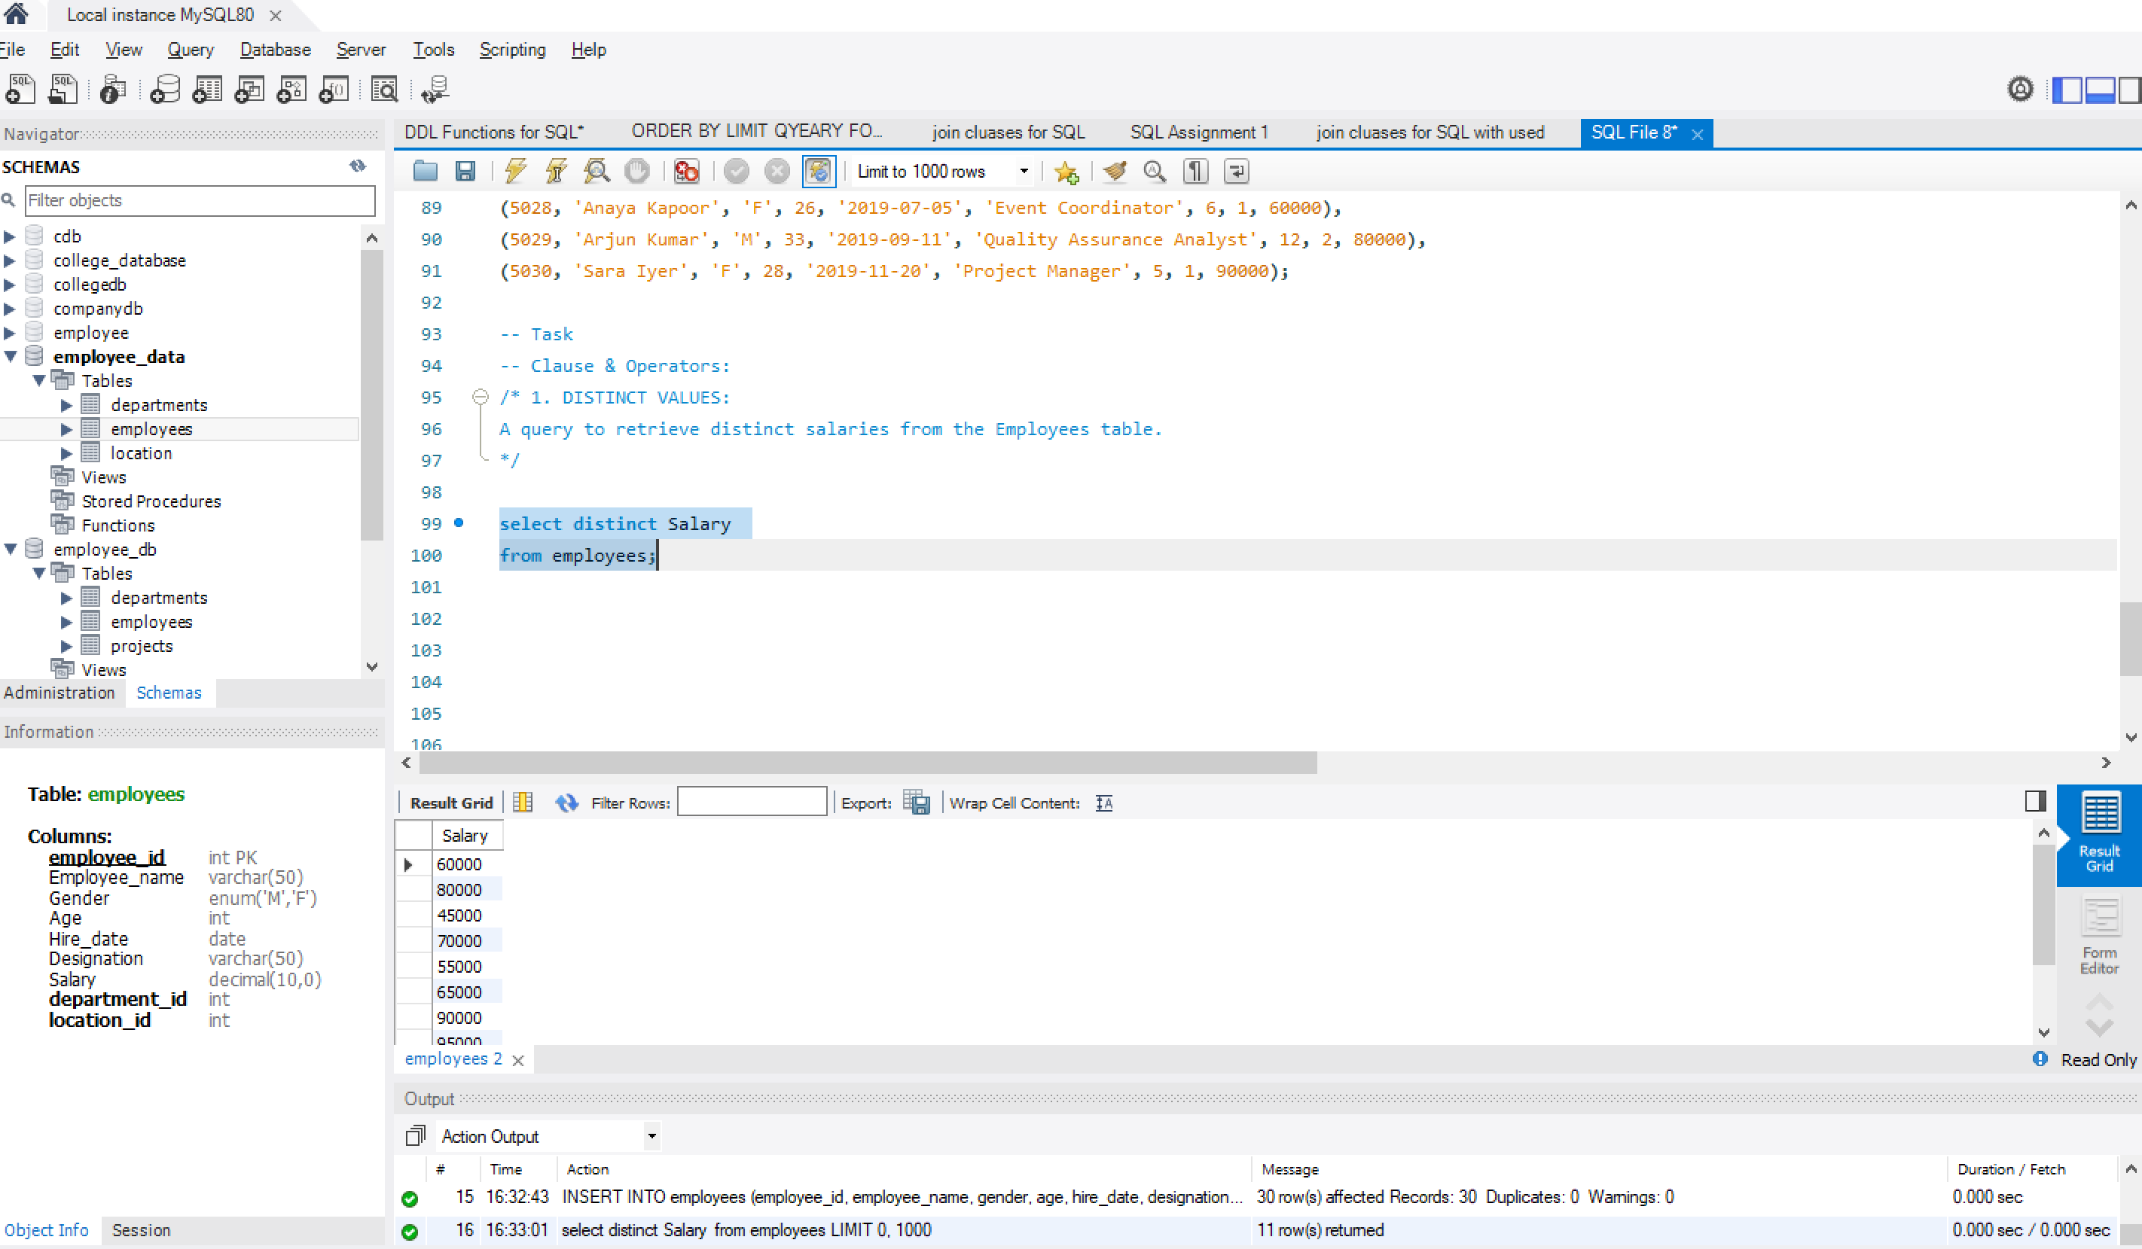
2. ALIAS (AS):
* Provide aliases for the "age" and "salary" columns as "Employee_Age" and "Employee_Salary", respectively.
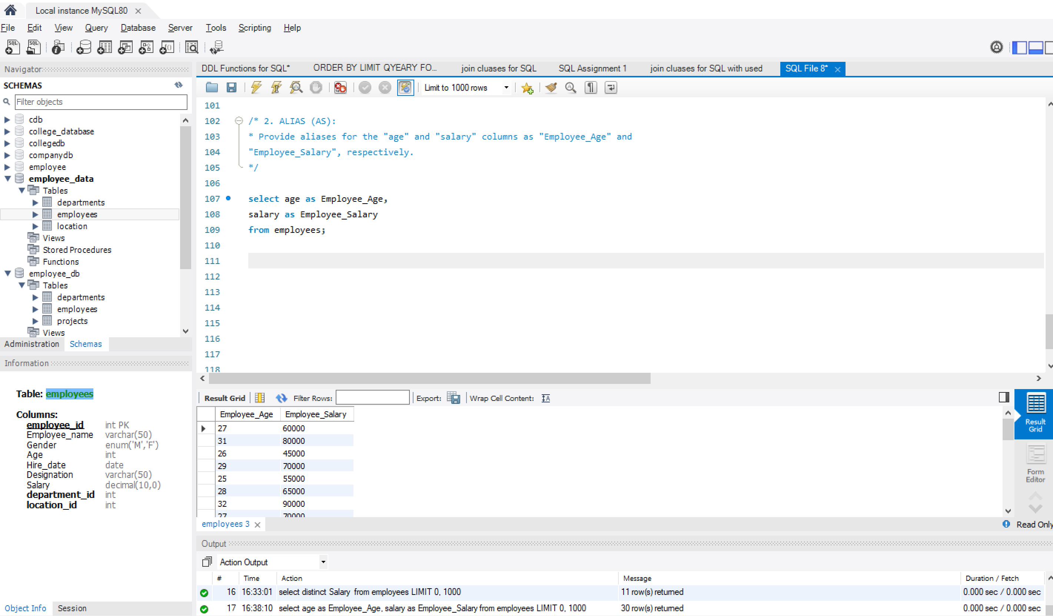
3. WHERE CLAUSE & OPERATORS:
- Retrieve employees with a salary greater than ₹50000 and hired before 2016-01-01.
- Find the employee whose designation is missing and fill it with "Data Scientist".
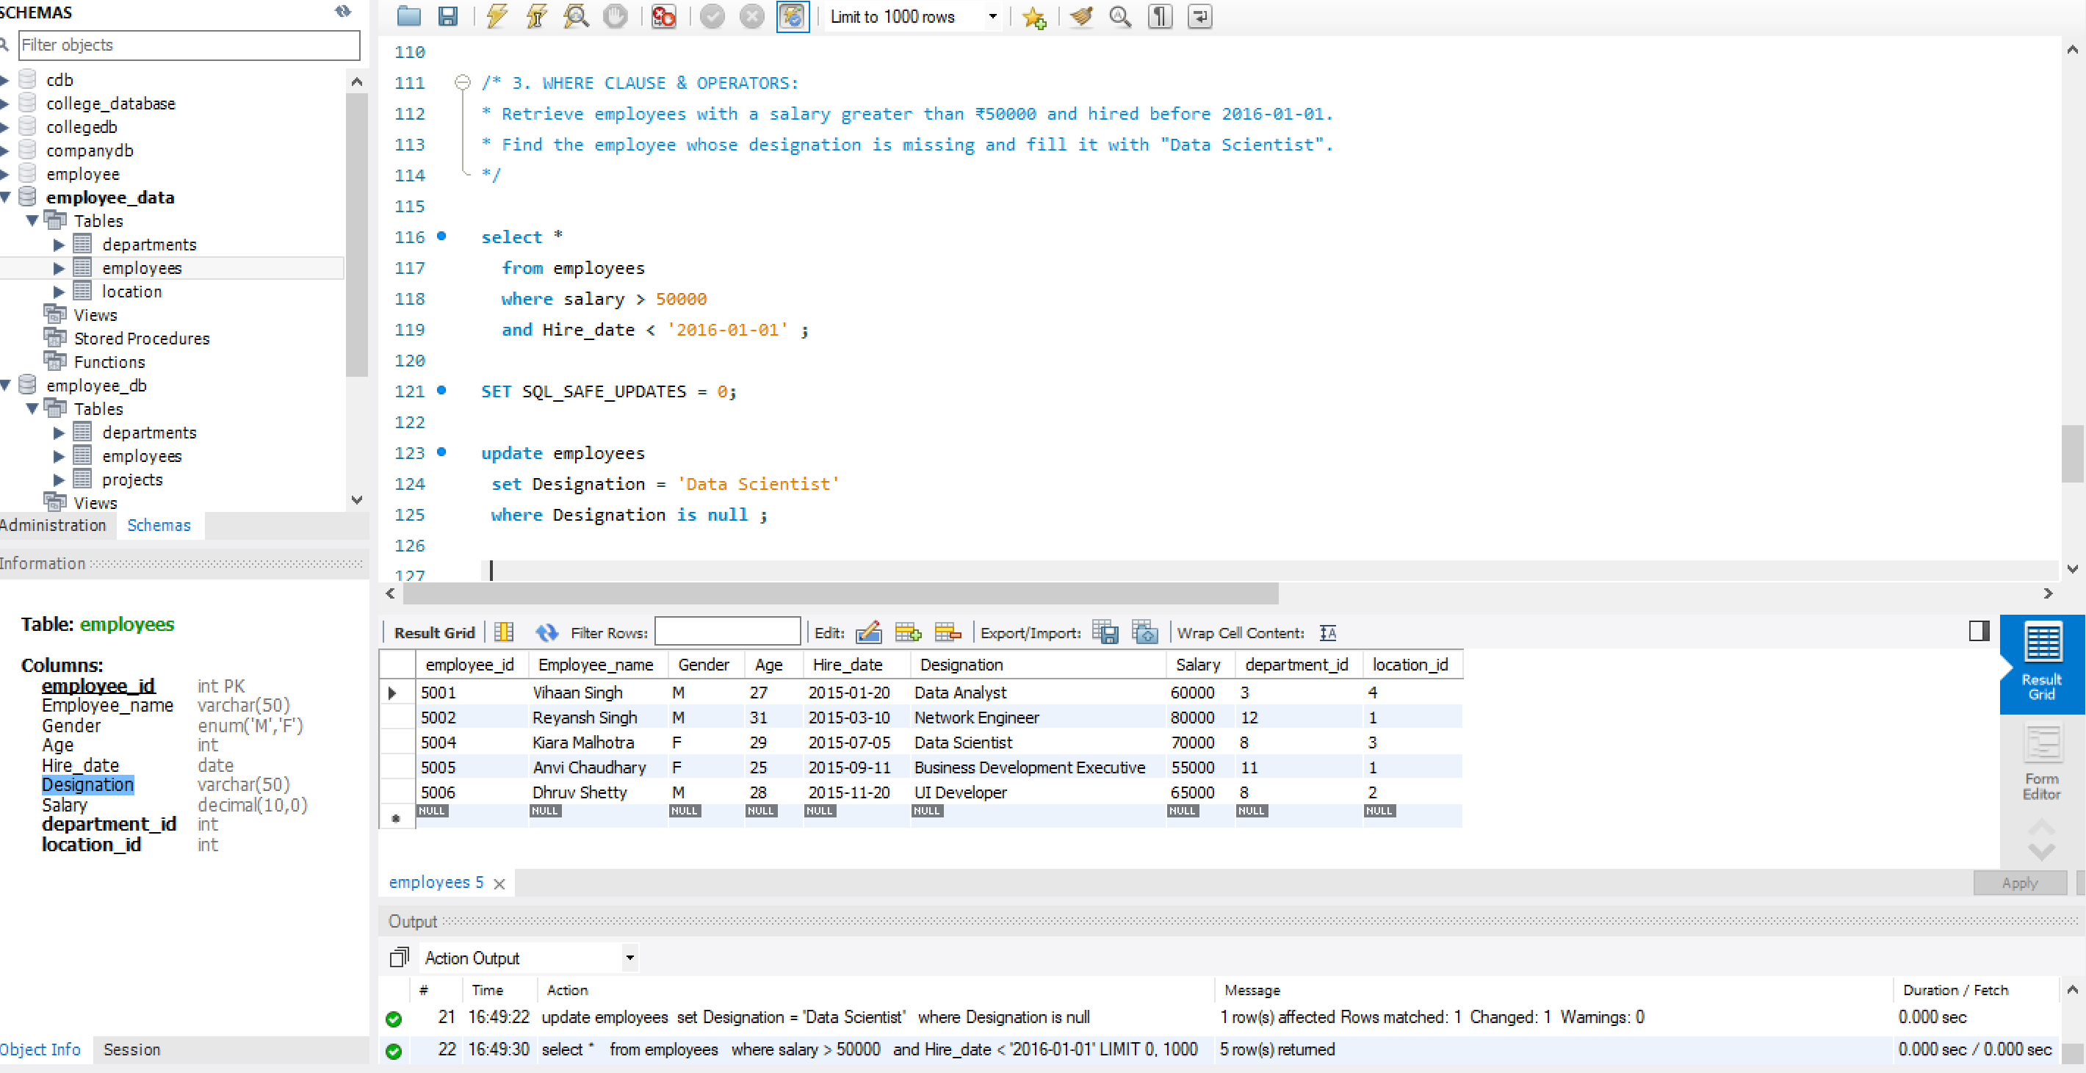
Sorting and Grouping Data:
- ORDER BY:
- Find employees sorted by department ID in ascending order and salary in descending order.
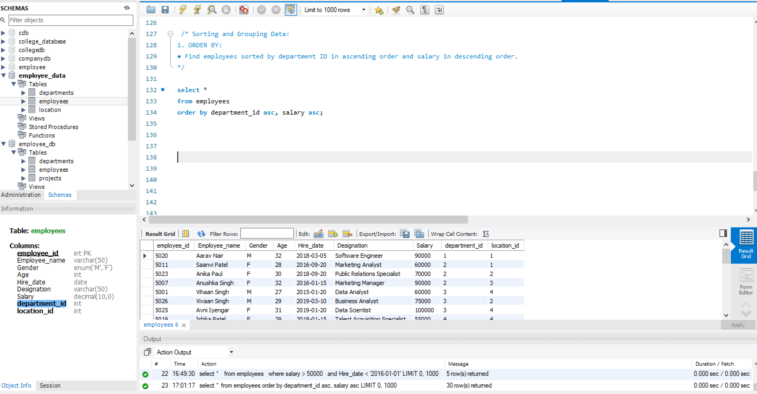

2. LIMIT:
- Display the first 5 employees hired in the year 2018.
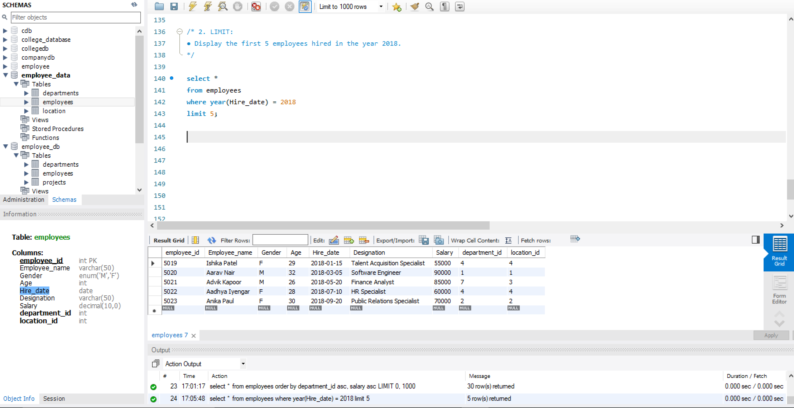
3.AGGREGATE FUNCTIONS:
- Calculate the sum of all salaries in the Finance department.
- Find the minimum age among all employees.
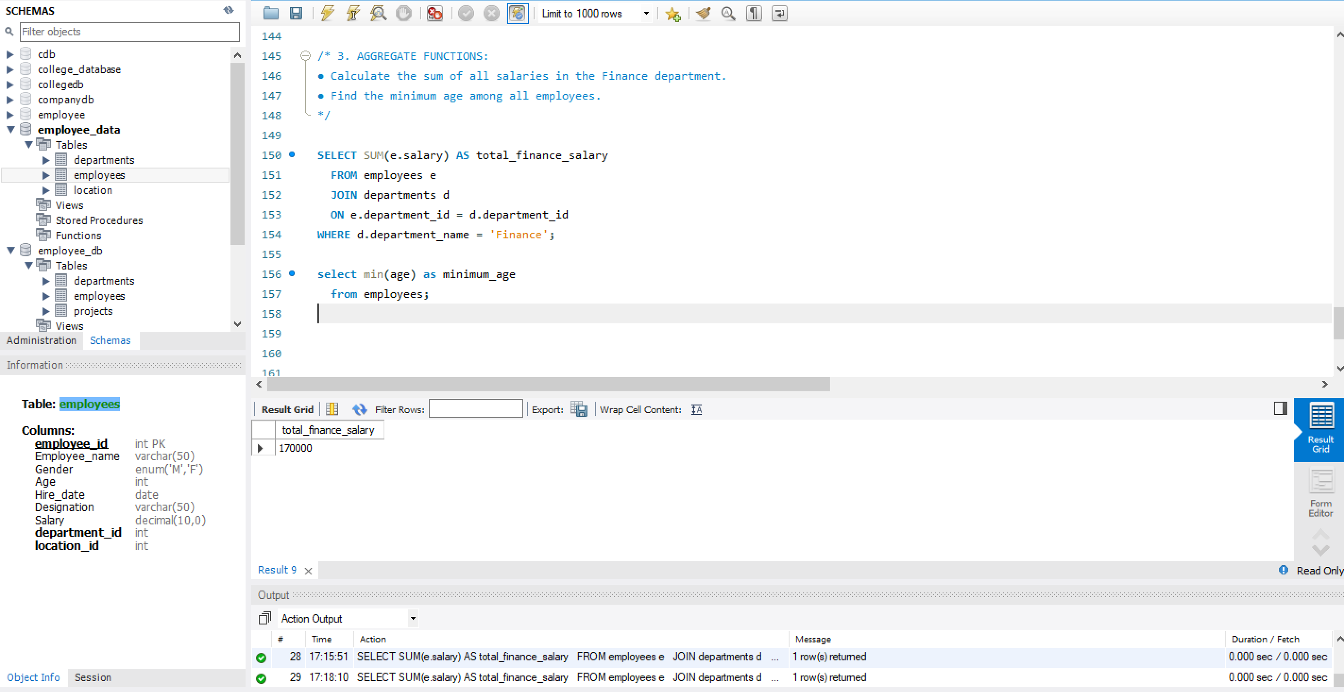
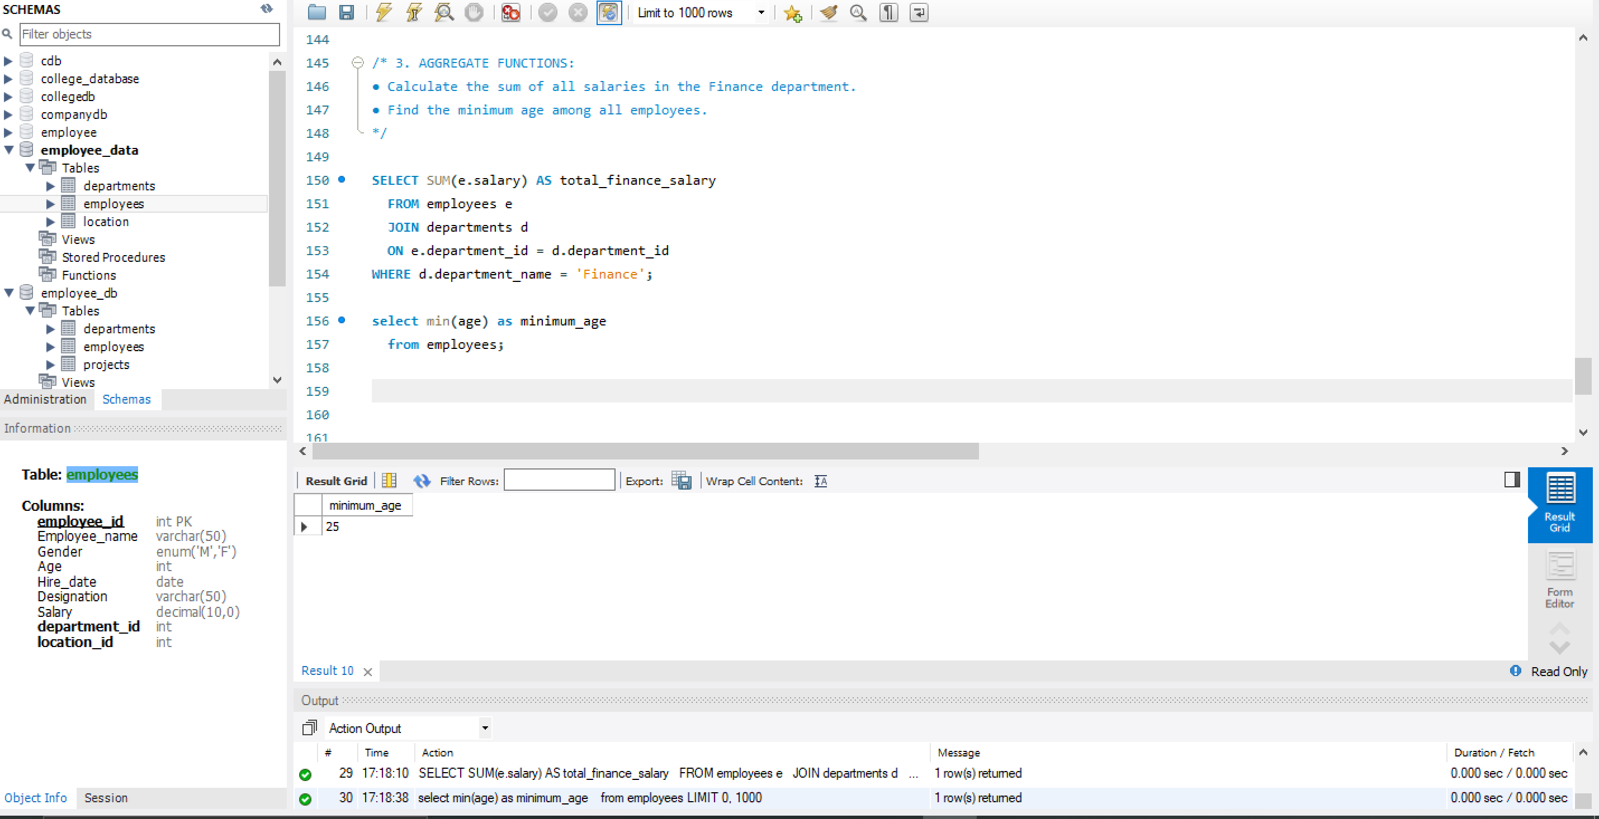

4. GROUP BY:
- List the maximum salary for each location.
- Calculate the average salary for each designation containing the word 'Analyst'.
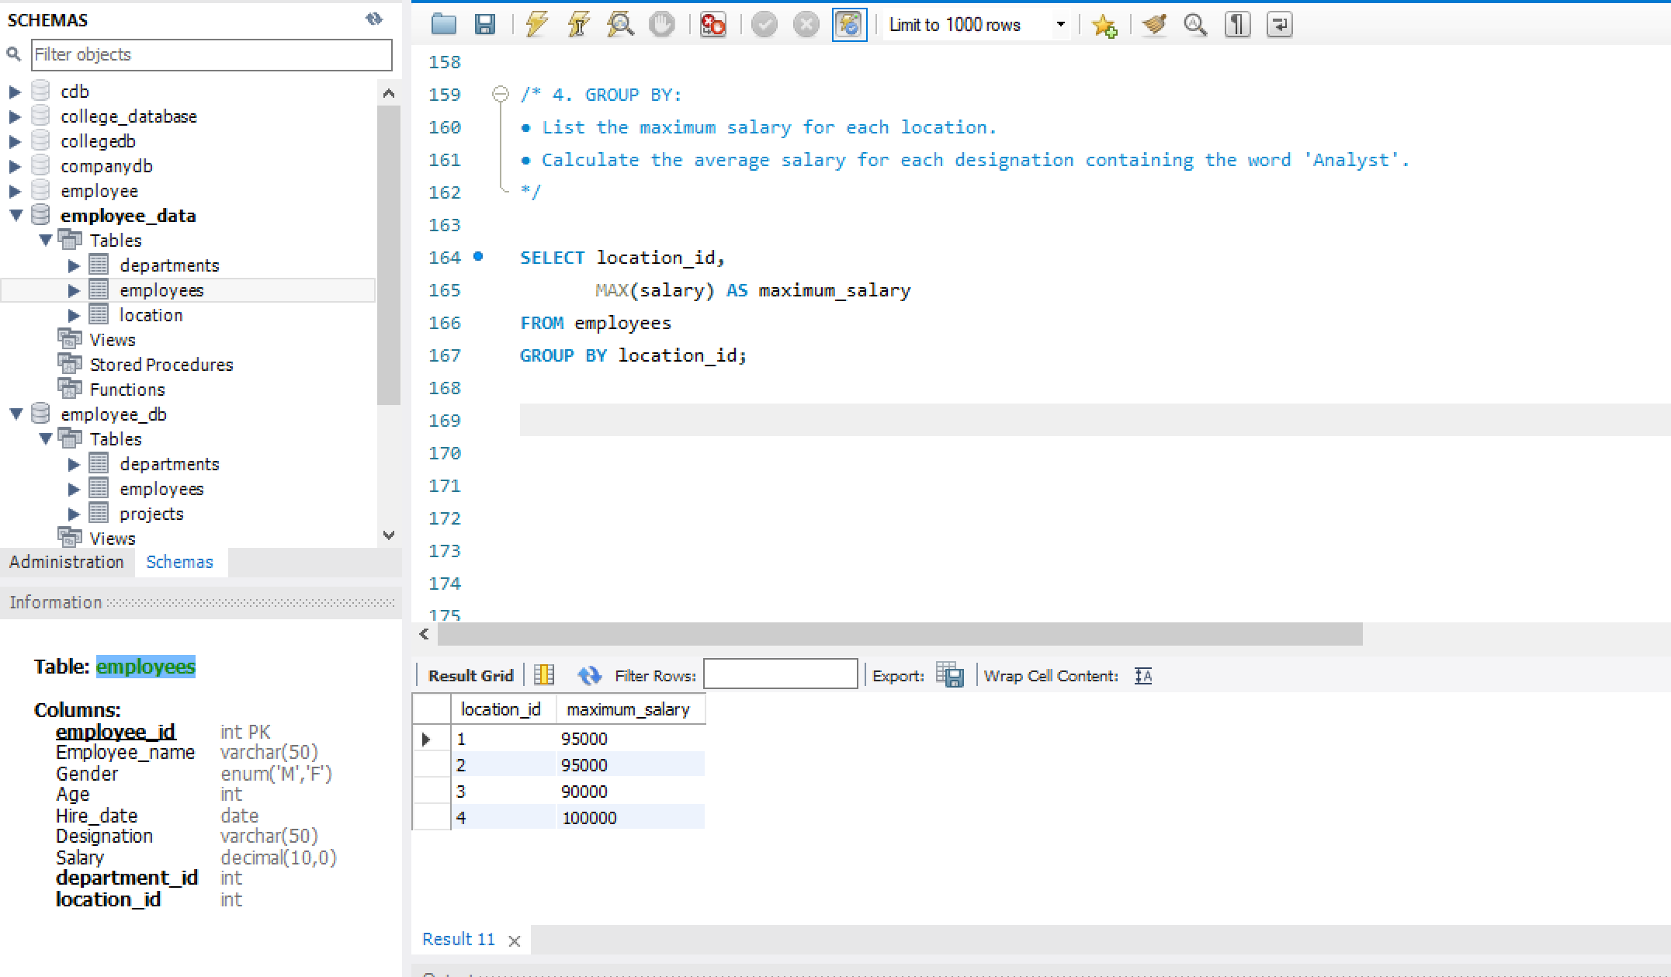
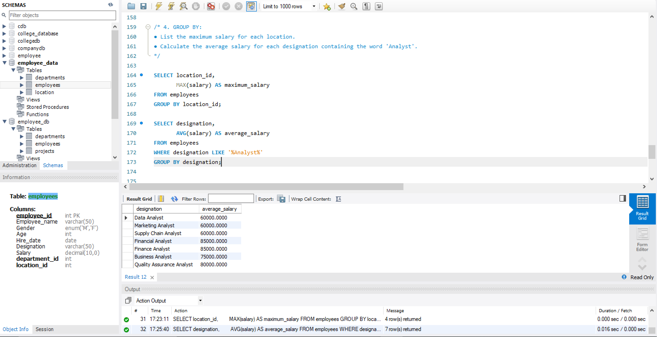
5. HAVING:
- Find departments with less than 3 employees.
- Find locations with female employees whose average age is below 30.
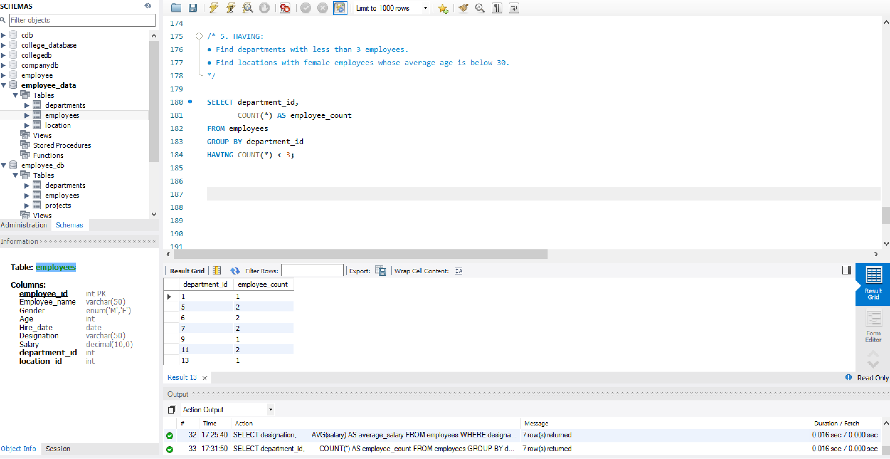
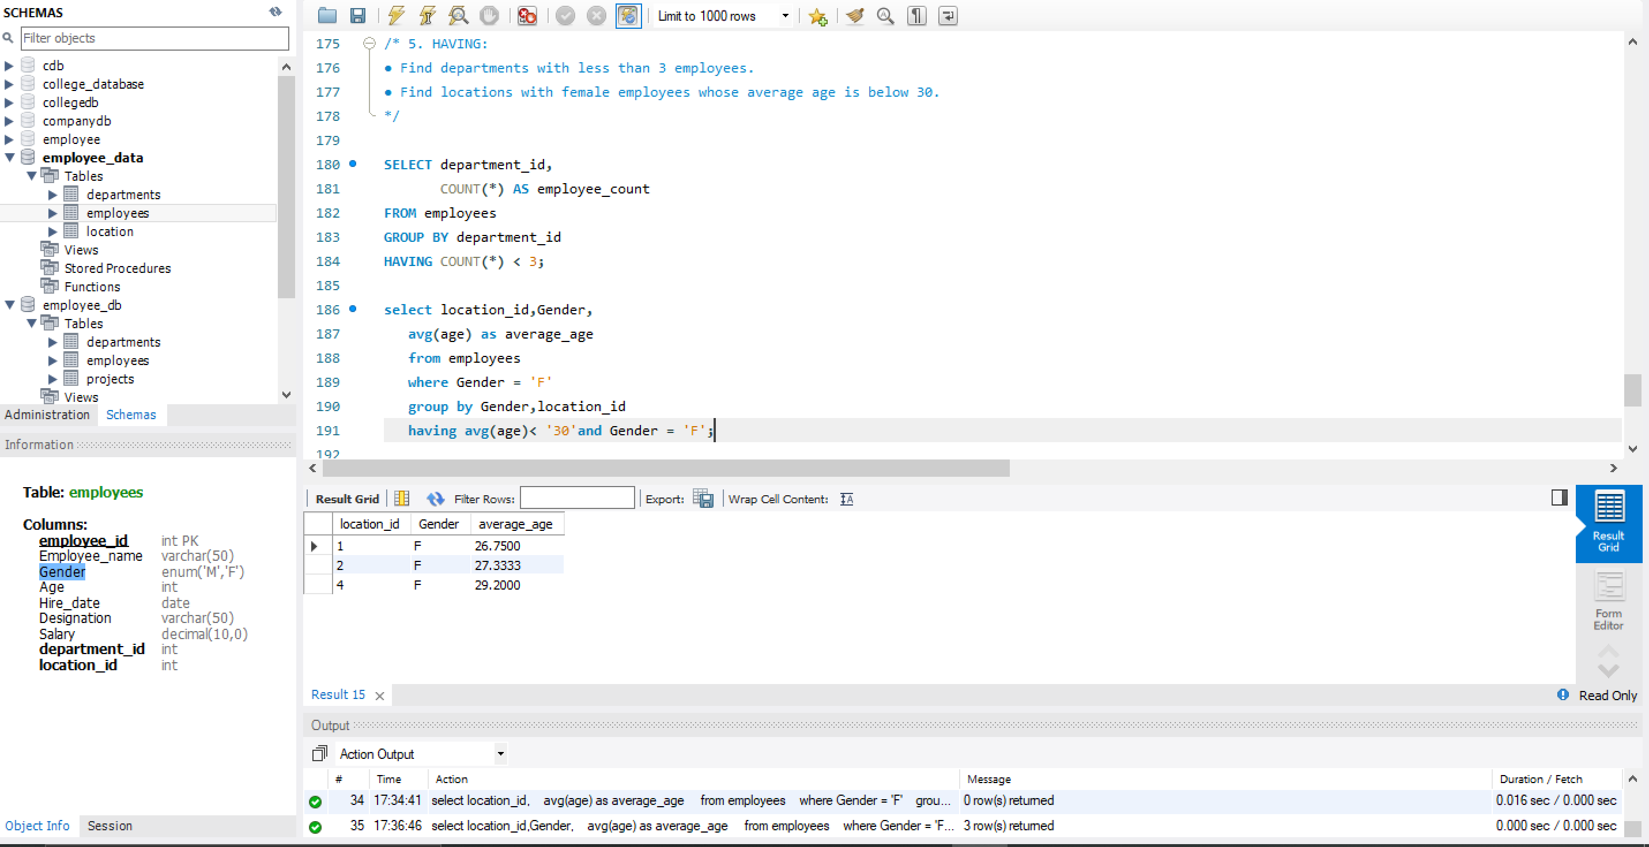

Joins:
1.INNER JOIN:
- List employee names, their designations, and department names where employees are assigned to a department.
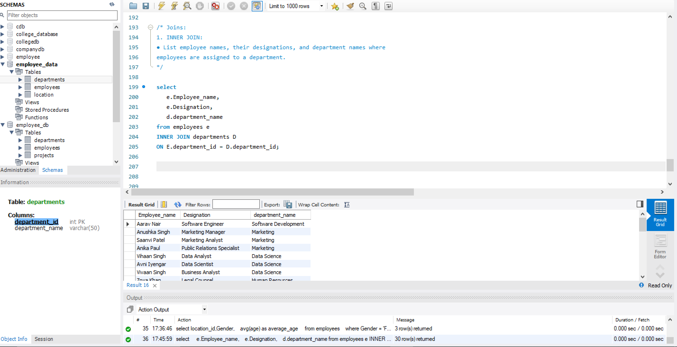
2.LEFT JOIN:
- List all departments along with the total number of employees in each department, including departments with no employees.
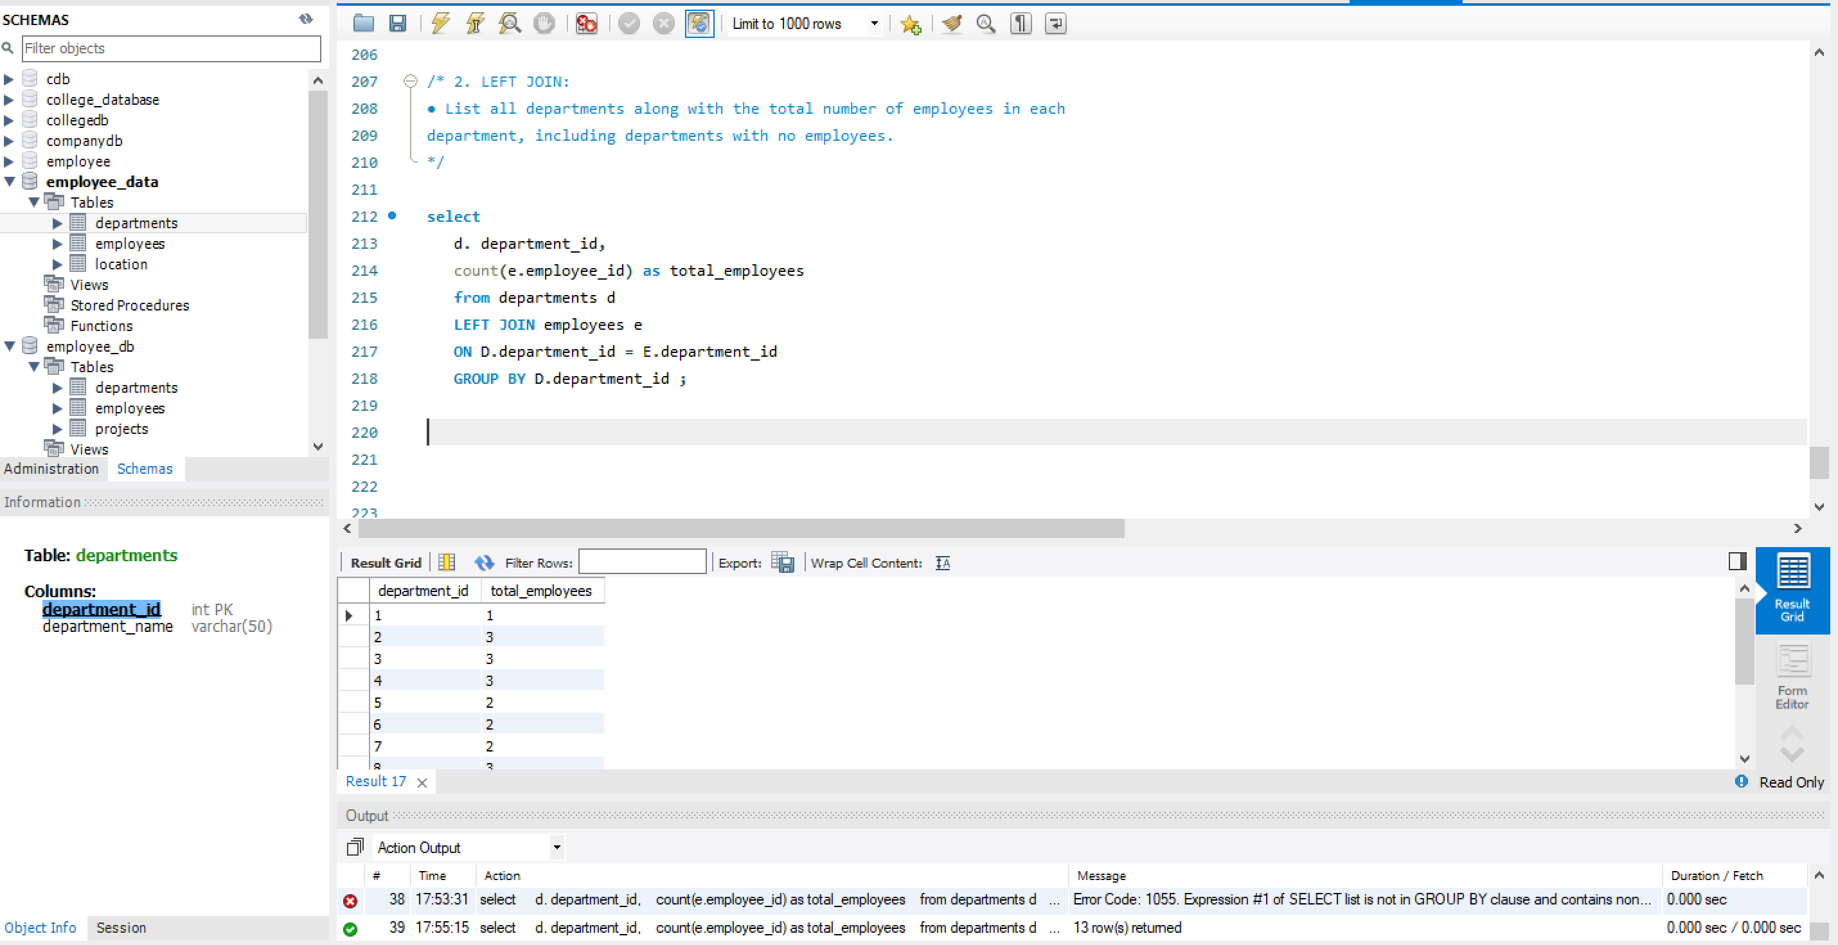

3. RIGHT JOIN:
- Display all locations along with the names of employees assigned to each location. If no employees are assigned to a location, display NULL for employee name.
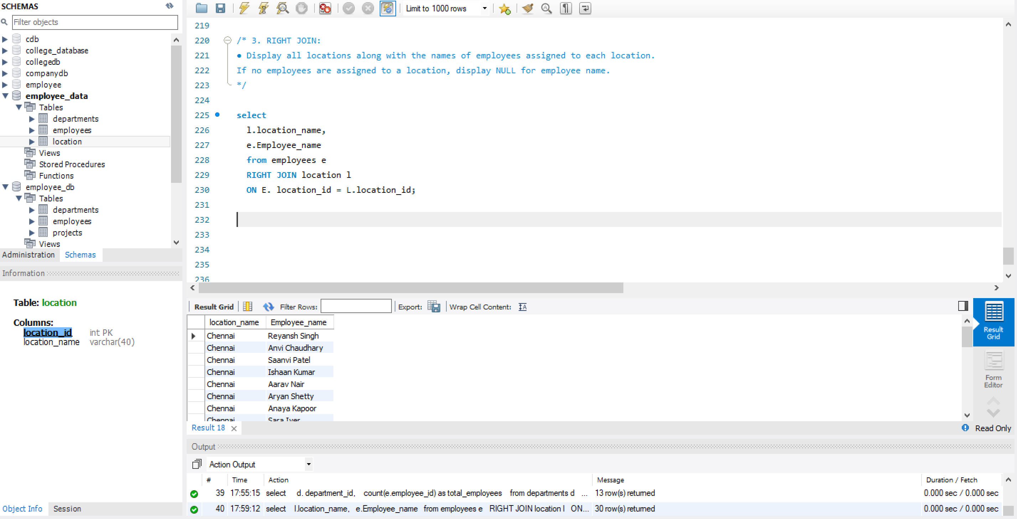
4. CROSS JOIN
- Show all possible combinations of departments and locations.
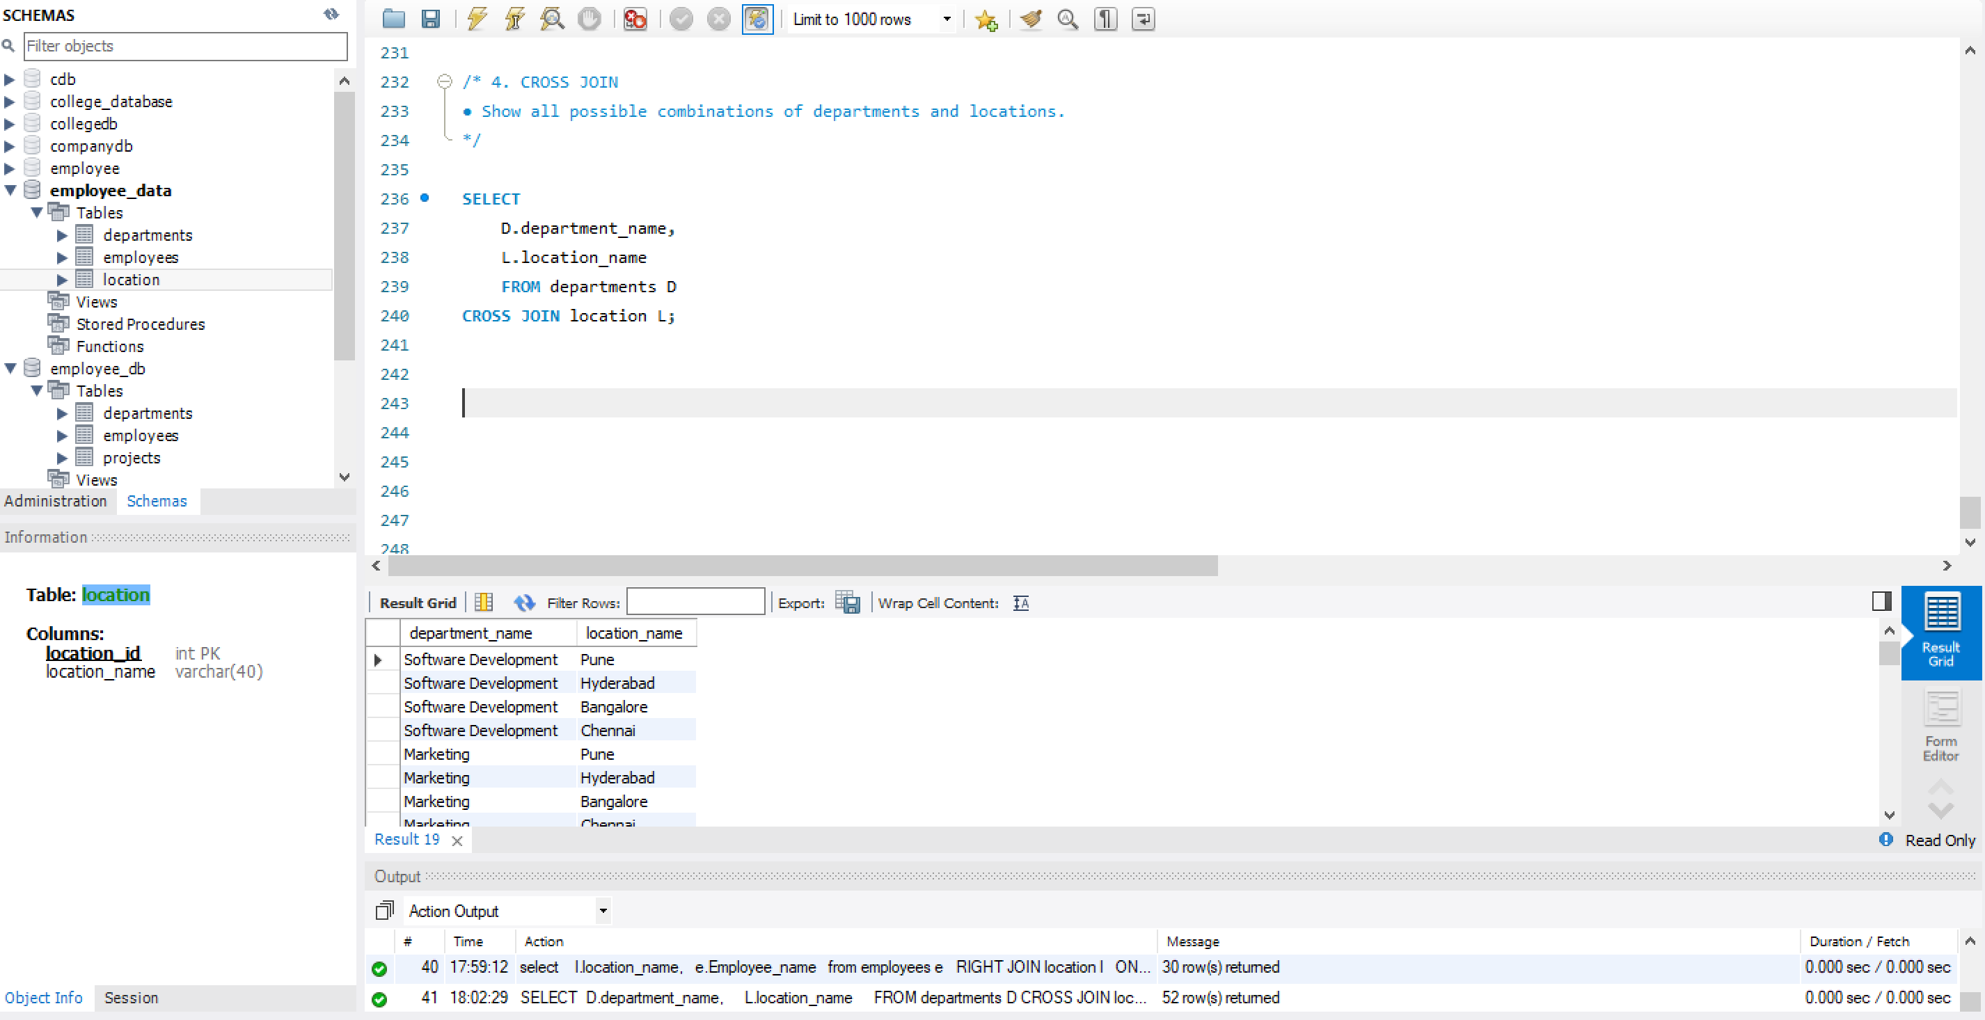
5. SELF JOIN:
- Show pairs of employees working in the same department, excluding self-pairs.
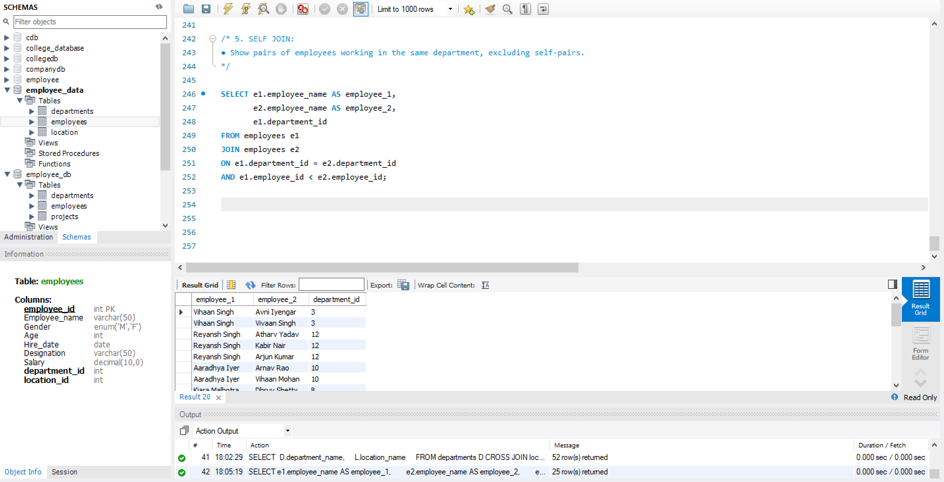

Windows function
- Write a window function query to rank employees by salary using rank().
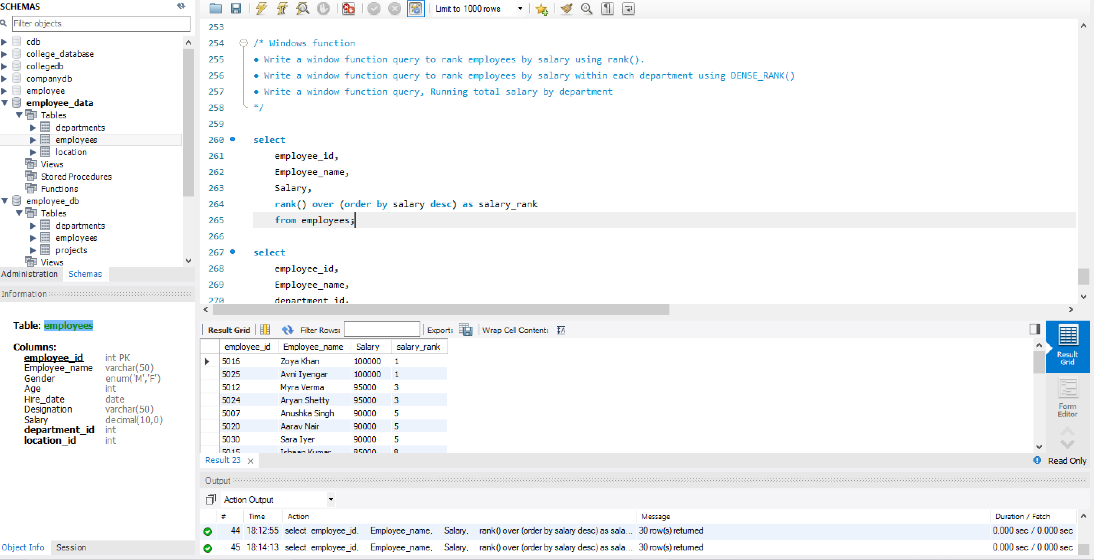
- Write a window function query to rank employees by salary within each department using DENSE_RANK()
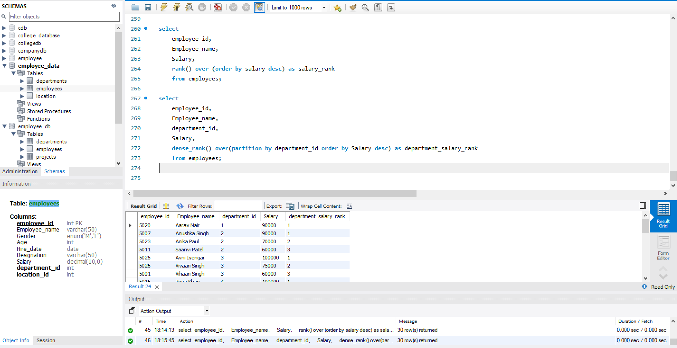
- Write a window function query, Running total salary by department
